

SINDH MADRESSAH TUL ISLAM BOARD

For the Period: 17th February to 16th May, 2025
Prepared by: Hira Bilquees (Education Expert)
Schools Involved: GGSS Sindh jamat housing society, GGSS no 9 sector 8L,GGSS frontier colony no 1, GGSS warayo gabol school.
Date of Submission: 12th June, 2025

1. Introduction
This report outlines the CPD activities conducted between 17th February and 16th May 2025 across four schools managed under the Sindh Madressah-tul-Islam Board (SMB). It builds on the training efforts completed during Winter 2024, where four full-day sessions were held on the following dates:
- 21st December 2024 – Classroom Management (Day 1) Held in the auditoriums of each school.
- 23rd December 2024 – Classroom Management (Day 2) Held in the auditoriums of each school.
- 24th December 2024 – IT Training (Day 1) Conducted in the computer labs of each school, with hands-on practice.
- 28th December 2024 – IT Training (Day 2) Conducted in the computer labs of each school, with hands-on practice.
These trainings introduced practical strategies for improving classroom discipline, digital lesson planning, and student engagement.
However, in this quarter, full CPD sessions were not possible due to early school closure in March 2025 (per government orders), and the focus shifted toward final examination preparation. Despite this, refresher activities and peer support sessions were conducted in some schools.

2. CPD Activities (Feb–May 2025)
Short, school-based refresher sessions were organized in February in the following schools:
- GGSS no 9 sector 8L,GGSS frontier colony no 1: Peer-led follow-ups on classroom routines and engagement methods
- GGSS Sindh jamat housing society: Review of digital tools including MS Word, Google Slides
- GGSS Warayo Gabol School: Basic IT awareness session using few functional PC (due to solar power issues)

3. Participation and Engagement
- EMO Teachers
EMO teachers across all four schools remained committed, attended all sessions, and applied training strategies consistently in their classrooms.
- Government Teachers
Government teacher participation showed improvement in GGSS Sindh jamat housing society and GGSS frontier colony no 1. However, in GBSS No. 9, Sector 8L, some government teachers remained non-participative throughout the quarter.

4. Non-Participation Note
Despite reminders and follow-up efforts, the following government teachers from GBSS No. 9, Sector 8L did not attend any CPD sessions and did not show interest in participating:
- Mr. Talha
- Mr. Saifullah
- Mr. Fareed
Repeated verbal and written reminders were issued through school leadership, but there was no response or engagement.

5. Challenges
- Short Academic Term:
Due to early session closure in March 2025, there was limited time for structured CPD activities.
- Technical Barrier at GGSS Warayo Gabol:
Solar power issues prevented proper IT training. Only few computer was functioning, which limited interactive learning.

6. Strategic Response
- Maximized February Time:
Brief in-school CPD refreshers and peer-sharing circles were conducted before exam season began.

- 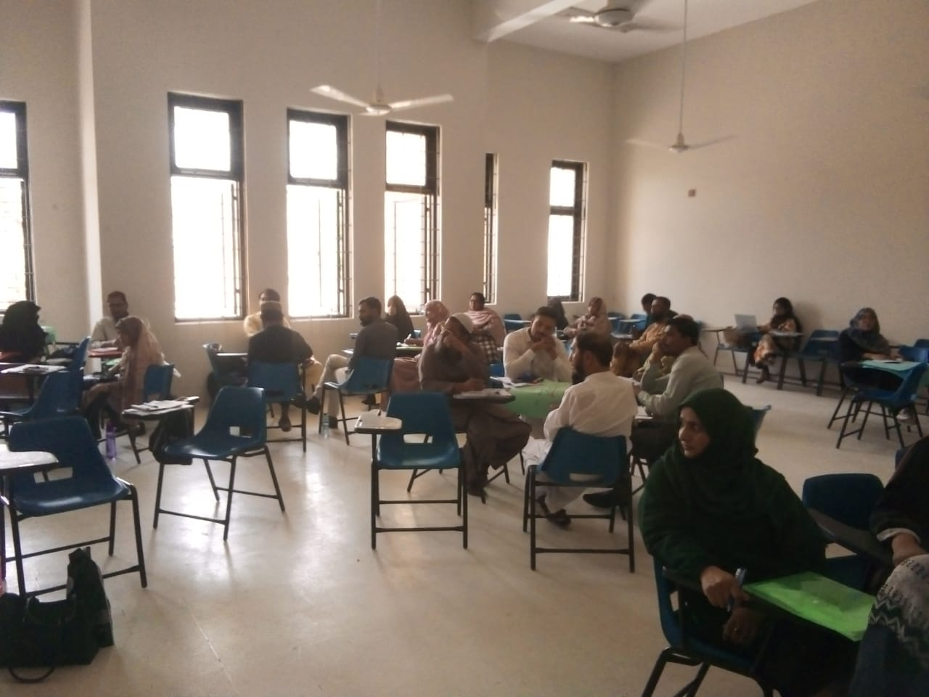 CPD recap session conducted at Frontier School. EMO teachers facilitated group discussions on managing disruptive behavior and using positive reinforcement strategies.
- 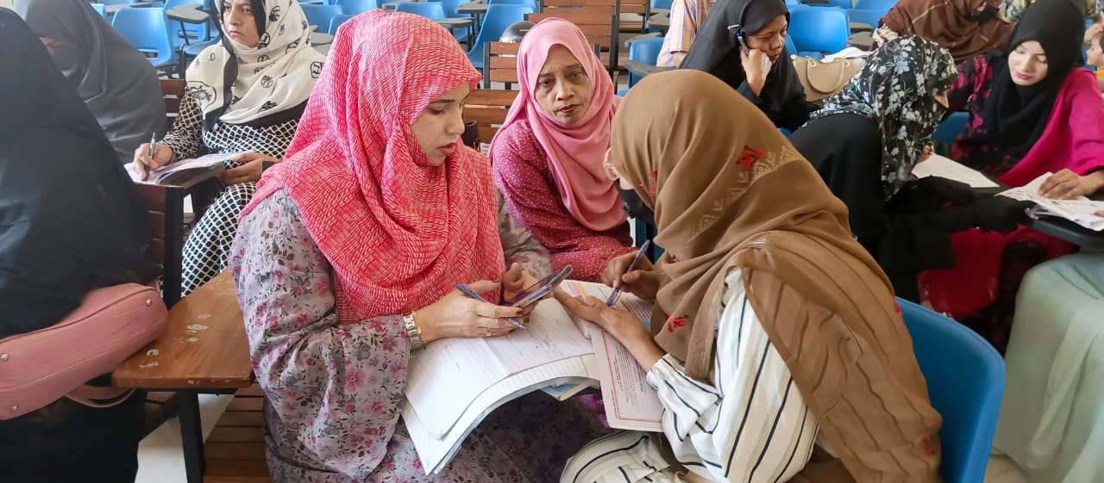Peer sharing circles were conducted by various teachers as a follow-up to the training sessions.
- 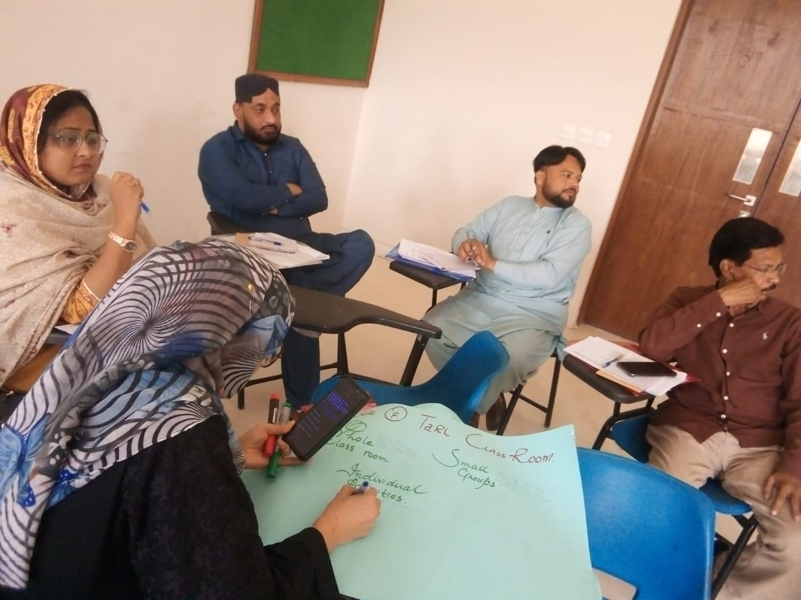EMO and government teachers collaboratively writing on charts during a recap session. This reflective activity helped reinforce classroom routines and student engagement methods.
- 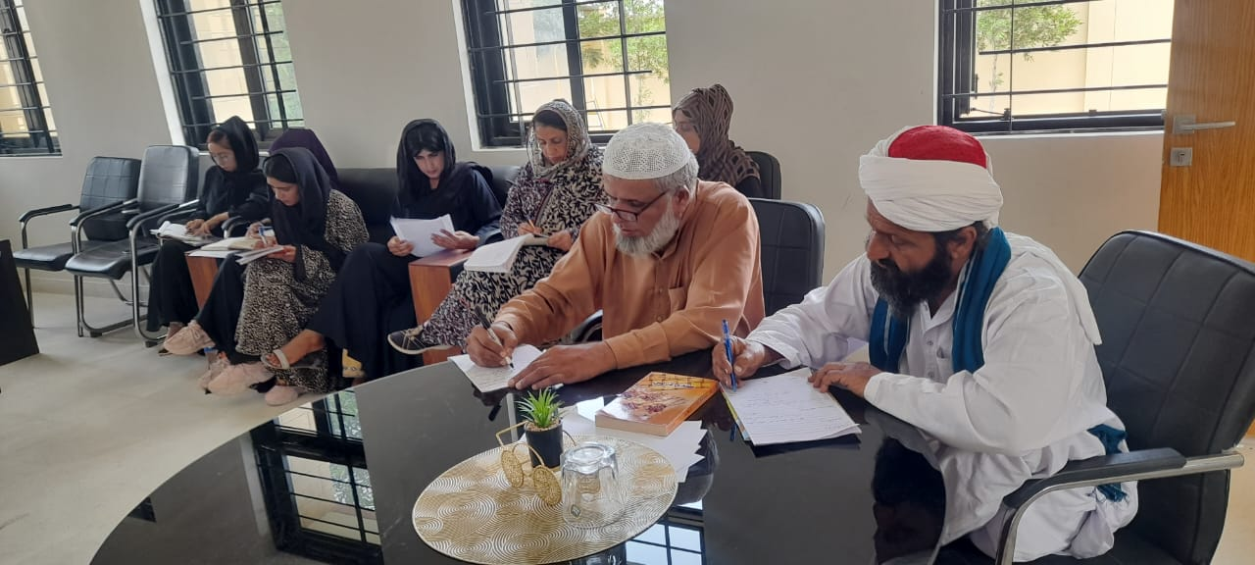Teachers at GGSS Warayo Gabol School actively noting down key points during a one-day CPD follow-up session. The activity focused on revisiting strategies from the December 2024 training on classroom management and IT tools.

- Summer CPD Plan (June–July 2025):
To complete the annual CPD target, an extended training program is scheduled for summer. It will include:
  - Practical IT sessions (Google Workspace, Canva, digital assessments)
  - Classroom Management workshops
  - Peer review and micro-teaching rounds
- Engagement of External Trainers:
For the first time, external expert trainers will be invited to lead summer workshops to provide advanced techniques, new methodologies, and increased teacher motivation.
- Monitoring and Accountability:
Attendance and engagement will be tracked, and coordination with school heads will ensure compliance.

8. Feedback Summary
Based on training feedback forms collected in December 2024:
- 90% of participants rated the training as “useful” or “very useful”
- 87% felt more confident applying classroom management strategies
- 78% felt confident using IT tools in teaching
- Trainers were rated as knowledgeable and encouraging participation

9. Conclusion
Although this quarter faced time and infrastructure limitations, the CPD team managed to continue efforts through refresher activities and peer support. EMO teachers remained consistent, and government teacher engagement showed signs of improvement. With the launch of the June–July summer CPD program, including external expert trainers, the overall capacity-building goals for the academic year are expected to be successfully met.

Plan
- Resolve the solar issue at GGSS Warayo Gabol to enable future IT training.
- Ensure active participation from all teachers in the summer CPD.
- Utilize external trainers to enhance quality and variety of training.
- Track and document all summer CPD progress for evaluation and reporting.
- observations helped reinforce CPD strategies.

